**Exploring Weather Trends**

Analyzing Mecca(KSA) and Global temperatures

1. Applications used are SQL & EXECL.
2. Queries and codes that has been used to extract the data as follow:

* Query about cities in Saudi Arabia:

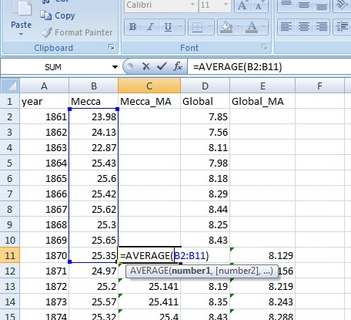SELECT *

FROM city_list

WHERE country LIKE ‘Sau%’;

(Riyadh & Mecca) have been found.

* Download Mecca data:

SELECT year, avg_temp

FROM city_data

WHERE city IN (‘Mecca’);

* Download Global:

SELECT *

FROM global_data;

1. Excel sheet were adjusted and combined both Mecca and Global data in one sheet and created a moving average column for each by using average function in excel for the average of 10 years, then copy the same function to lower cells.
2. Making a chart shows the data of moving average of Mecca and global with title name for the X & Y axis.

* Moving average temperatures of Mecca(KSA) have been compared to moving average temperatures of Global between 1961 and 2013.
* Below chart show obviously that average temperature of Mecca is hotter than average temperature of the globe and that is consistently over 150 years.
* Highest level that has been recorded in Mecca was in 2013 (27.57), where the trend of average temperatures were going higher, while the temperature on the globe recorded (9.61) in the same year and that also is the highest level that has been recorded for the globe.
* Charts shows the globe is going hotter than before.
* Significant change in globe temperature started by the end of last century till 2013, as per the chart.
* In between 1939 and 1981, temperature was a quit stable, as per the chart.